Criar Validação Para Checkout – API

Criar arquivo CheckoutRequest.php

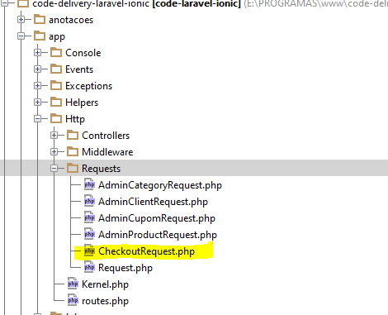

**<?php  
  
namespace** CodeDelivery\Http\Requests;  
  
**class** CheckoutRequest **extends** Request  
{  
 */**  
 * Determine if the user is authorized to make this request.  
 *  
 \** ***@return*** *bool  
 */* **public function** authorize()  
 {  
 **return true**;  
 }  
  
 */**  
 * Get the validation rules that apply to the request.  
 *  
 \** ***@return*** *array  
 */* **public function** rules()  
 {  
 *//Se exixstir o cupom code e se ele ja foi utilizado* **return** [  
 **'cupom_code'** => **'exists:cupoms,code,used,0'** ];  
 }  
}

Passar a validação para ClientCheckoutController em Api

**public function** store(Requests\CheckoutRequest $request)  
{  
 $data = $request->all();  
 $id = Authorizer::*getResourceOwnerId*();  
 $clientId = $this->**userRepository**->find($id)->**client**->**id**;  
 $data[**'client_id'**] = $clientId;  
 $order = $this->**orderService**->create($data);  
 $order = $this->**orderRepository**->with([**'items'**])->find($order->**id**);  
 **return** $order;  
}

IMPORTANTE – Passar por Header Accept = application/json

